Ovarian Cancer
- The most common cause of gynecologic death
- Peak incidence: age 65–75 years
- Prevalence: 1 in 70 (1.43%)
- Most common stage @ diagnosis = stage 3
- Rf: old age, family hx, infertility, late menopause, nulliparity
- Protective factors: hormonal contraception (OCP decreases risk by 30-50%), tubal ligation (decreases risk by 65% if salpingectomy; 25% if no salpingectomy), hysterectomy
- Sx: vague gastrointestinal symptoms, early satiety, bloating, abdominal or pelvic pain
  - Hydrops tubae profluens: colicky lower abdominal pain relieved by a profuse, serous, watery, yellow vaginal discharge (very rare but pathognomonic of primary tubal cancer)
- PE and imaging: adnexal mass
- Most common histologic type: epithelial (serous) carcinoma
  - Tumor marker: CA 125
- Rule out germ cell tumors in patients < 30 years old with tumor markers such as hCG and AFP
Germ cell tumor
Dysgerminoma  (35-50%) | LDH, HCG | Significant bilateral involvement  Fried egg cells (cytoplasmic glycogen with PAS stain)
Embryonal | AFP, HCG | Syncytiotrophoblast-like tumor cells
Immature teratoma  (36%) | AFP, LDH, CA 125 | Immature neuroectodermal tissue
Choriocarcinoma | HCG | Sheets of anaplastic cytotrophoblasts and syncytiotrophoblasts without chorionic villi
Yolk sac tumor (endodermal sinus tumor)  (20%) | AFP, LDH | Shiller-Duval bodies (resemble glomeruli; a central capillary surrounded by connective tissue and a peripheral layer of columnar cells)
Gonadoblastoma | E2, inhibin, T, DHEA
Sex cord-stromal tumor
Granulosa cell | Inhibin, E2, T | Coffee bean nuclei, Call Exner bodies (microfollicular pattern with numerous small cavities that contain eosinophilic fluid)
Sertoli Leydig | AFP, E2, Inhibin, T, DHEA | Reinke crystal (crystals in cytoplasmic inclusions)
Fibroma/fibrosarcoma
Thecoma
Sclerosing stromal tumor
Epithelial carcinoma
Cystadenocarcinoma | CA 125 | Psammoma bodies (round central area with surrounding collections of calcium)
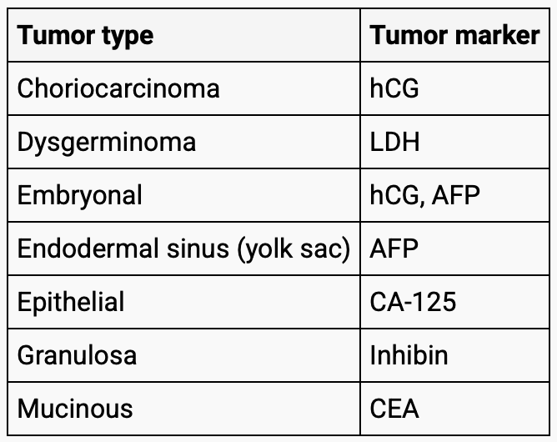
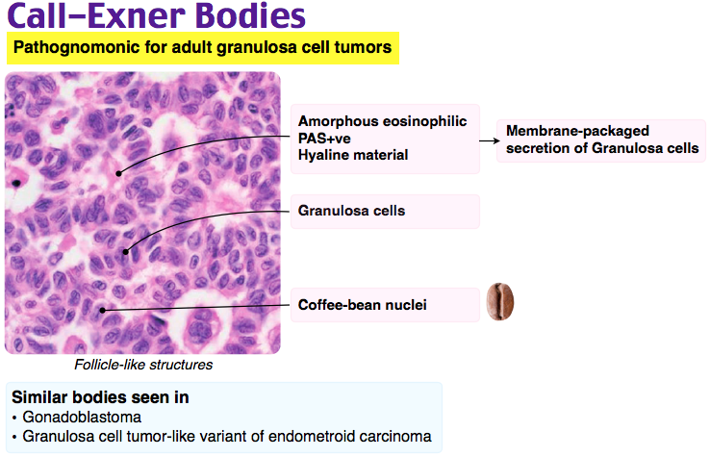
- Routine screening not recommended (lack of benefit)
- Most commonly spreads via exfoliation throughout the peritoneal cavity
  - Malignant cells follow the normal clockwise circulation of peritoneal fluid and implant in the R paracolic gutter and the undersurface of the R hemidiaphragm
- Surgical staging (10 steps)
  - Cytological evaluation of peritoneal fluid
  - Biopsy of the abdominal and peritoneal surfaces
  - Lymph node dissection (pelvic and infrarenal paraaortic lymphadenectomy)
  - Cytoreduction (debulking) of any visible tumors - optimal debulking is < 1cm of residual disease
  - Omentectomy: to reduce tumor bulk and to reduce postop ascites
    - In the absence of gross extraovarian disease, the infracolic omentum should be removed or at least biopsied
  - Hysterectomy
  - BSO
  - +/- appendectomy
- Laparoscopic evaluation of the abdomen and pelvis to determine whether the tumor volume is resectable might help surgeon decide whether the patient is a good candidate for up-front cytoreduction
  - To assess the chance of optimal cytoreduction
  - Score 10 or higher: the chance of achieving complete primary debulking was 0 → need NACT first
 | Score 2
Peritoneal carcinomatosis | Unresectable massive peritoneal involvement as well as with a miliary pattern of distribution
Diaphragmatic disease | Widespread infiltrating carcinomatosis or nodules confluent in most of the diaphragmatic surface
Mesenteric disease | Large infiltrating nodules or involvement of the root of the mesentery indicated by limited movement of the various intestinal segments
Omental disease | Tumor diffusion observed along the omentum up to the large stomach curvature
Bowel infiltration | Bowel resection assumed or miliary carcinomatosis on the serosa observed
Stomach infiltration | Obvious neoplastic involvement of the gastric wall
Liver mets | Any surface lesion

- Prognosis: 5 year survival rate is 50%
- Prevention:
  - COCs ↓ risk by 30–50%
  - Bilateral salpingectomy ↓ risk by 65% (specifically serous endometrioid and clear cell carcinomas)
Simplified staging
1A | Confined in one ovary/tube
1B | Both ovaries/tubes
1C1 | Spill during surgery | Chemo
1C2 | Rupture before surgery
1C3 | Malignant cells in ascites or peritoneal washing
2A | Uterus
2B | Bladder, sigmoid, rectum
3A | Peritoneum outside of pelvis, mets to the retroperitoneal lymph nodes | Surgical staging and debulking → 6 cycles IV paclitaxel followed by intraperitoneal carboplatin and intraperitoneal paclitaxel every 3 weeks  Platinum + Taxel (can be replaced by gemcitabine or doxorubicin) + Bevacizumab for those with suboptimal debulking
4 | Distant mets | Platinum + Taxel (can be replaced by gemcitabine or doxorubicin if getting peripheral neuropathy from taxel) + Bevacizumab
**Radiation is not indicated for metastasized disease since there is no good singular target for radiation

Ovarian Germ Cell Tumors
- Dysgerminoma
  - >98% survival rate with platinum-based agents
Stage IA and IB | Surgery
Stage IC, II, III | Surgery + BEP x 3 cycles
Stage IV | Surgery + BEP x 4 cycles

- Immature teratoma
Stage I, Grade 1 | Surgery
Stage I Ruptured or Grade 2 or 3, or Stage II/III | Surgery + BEP x 3 cycles
Stage IV | Surgery + BEP x 4-6 cycles

Ovarian Fibroma
- Pure stromal tumors - the most common benign sex cord stromal tumors
- Made of fibroblastic spindle cells
- Age 40+
- Ultrasound finding: solid and hypoechoic
- CT findings: Homogeneous, solid, and have delayed contrast enhancement with or without calcification
  - CT can help exclude other cases of ascites, especially carcinomatosis
- CA 125 will be elevated
- Treatment: UO/BS; should send frozen section intraop
- Complications
  - Meigs syndrome (hydrothorax, ascites, ovarian tumor)

